**CHAPTER 5**

**PROJECT DESCRIPTIONS**

**5.1. PROBLEM DEFINITION**

Car parking is a major problem in urban areas in both developed and developing countries. Following the rapid incense of car ownership, many cities are suffering from lacking of car parking areas with imbalance between parking supply and demand, which can be considered the initial reason for metropolis parking problems. This imbalance is partially due to ineffective land use planning and miscalculations of space requirements during first stages of planning. Shortage of parking space, high parking tariffs, and traffic congestion due to visitors in search for a parking place are only a few examples of everyday parking problems.

**5.2. THE SCENARIO**

The parking scenario is woefully falling short of the current requirements in the country. The situation is such that on any given working day approximately 40% of the roads in urban India are taken up for just parking the cars. The problem has been further exacerbated by the fact that nowadays even people from low income group are able to own cars. The number of families with cars has become much more than what the country is able to manage.

As it is, the cities in India are highly congested and on top of that the parked cars claim a lot of space that could otherwise be used in a better way. Thanks to poor, and at times zero, navigability, Indian cities are regarded as some of the worst options for living. One can also add the issue of pollution to this mix and understand the enormity of the crisis. In this context it needs to be understood that the Indian cities, with the possible exception of Chandigarh, were never planned in such a way so as to accommodate a deluge of cars as is the situation now.

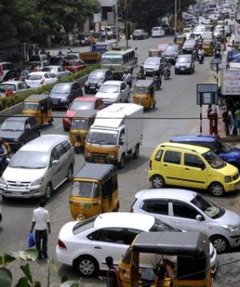

Figure 13: Scenario of Car Parking

**5.3. PROBLEMS’S SOLUTION**

One feels that the authorities who plan the Indian cities should really look into the situation. The public policy needs to be structured in such a way that the issue can be tackled effectively. One way to handle this is to take away the subsidy provided for parking. The charges for parking should be determined as per the land value of the particular area or the rent that is being charged for the same. It is also important that major sites of tourist interest, the heritage zones and shopping areas are made strictly off limit for cars. Smart city uses the information, communication and technologies to improve the operational efficiency for the public, helps in accelerating towards the improvement quality of life for citizens. Internet of Things (IOT), Automation, and Machine Learning are the emerging trends which drive towards smart city adoption.

Any city can be considered for smart city initiative, by introducing system like, smart parking system that help the drivers to locate parking slots, smart traffic management

to track and analyse the traffic flows in India. Sharing information electronically, monitor the environment changes enabled sanitation etc.

The strategic components are used to develop smart city mission improvement, smart innovation, energy, smart transportation, smart traffic light ,automatic street light, smart parking, smart innovation on thinking and etc.,. Any smart applications include sensors, which are deployed in environment, collects the information from device/sensor are processed and analysed to manage the applications. This approach would reduce the cost man power and increase the productivity.

The Internet of Things (IOT) is set of physical devices, vehicles, home appliances, embedded with electronics, software, sensor, actuator and network connectivity which enable to connect and exchange data. It facilitates connections beyond Machine-To-Machine communications, involving various protocol, domains and real-time applications.

Sensors can be networked together to sense several physical phenomena such as soil, vegetation, water bodies, habitat monitoring, object tracking etc. Smart parking system is a classic example demonstrates how the Internet-of-Things will be effectively and efficiently used to make life easy for a common citizen. Main purpose of smart parking system is to reduce time to locate the parking areas, hence to it reduces fuel consumption.

Sensors would be deployed in the parking area and through the mobile app, user books for the parking slot and allows online payment option as well. Developing countries like India, face problem for large free parking space management. Conventional parking management systems use sensors and other communication module, but does not address solution for both open and closed parking space. That might be easiest way to find parking areas near by the people in this calamitous situation.